**LAB 7**

**OBJECTIVE**

To perform image segmentation and pattern recognition

**THEORY**

Image segmentation is a commonly used technique in digital image processing and analysis to partition an image into multiple parts or regions, often based on the characteristics of the pixels in the image. Image segmentation could involve separating foreground from background, or clustering regions of pixels based on similarities in color or shape.It involves converting an image into a collection of regions of pixels that are represented by a mask or a labeled image. By dividing an image into segments, you can process only the important segments of the image instead of processing the entire image. A common technique is to look for abrupt discontinuities in pixel values, which typically indicate edges that define a region.

Several algorithms and techniques for image segmentation have been developed over the years using domain-specific knowledge to effectively solve segmentation problems in that specific application area. These applications include medical imaging, automated driving, video surveillance, and machine vision.

Pattern recognition is the process of classifying input data into objects or classes based on key features. There are two classification methods in pattern recognition: supervised and unsupervised classification.

The supervised classification of input data in the pattern recognition method uses supervised learning algorithms that create classifiers based on training data from different object classes. The classifier then accepts input data and assigns the appropriate object or class label.In computer vision, supervised pattern recognition techniques are used for optical character recognition (OCR), face detection, face recognition, object detection, and object classification.

The unsupervised classification method works by finding hidden structures in unlabeled data using segmentation or clustering techniques. Common unsupervised classification methods include:K-means clustering,Gaussian mixture models, Hidden Markov models. In image processing and computer vision, unsupervised pattern recognition techniques are used for object detection and image segmentation.

Pattern recognition has applications in computer vision, radar processing, speech recognition, and text classification.

**CODE**

% Program 1 : Image Segmentation

im=imread('number_plate.jpg');

im1=rgb2gray(im);

% Median filtering the image to remove noise

im1=medfilt2(im1,[3 3]);

% Finding edges

BW = edge(im1,'sobel');

[imx,imy]=size(BW);

msk=[0 0 0 0 0;

0 1 1 1 0;

0 1 1 1 0;

0 1 1 1 0;

0 0 0 0 0;];

% Smoothing image to reduce the number of connected components

B=conv2(double(BW),double(msk));

% Calculating connected components

L = bwlabel(B,8);

mx=max(max(L));

[r,c] = find(L==17);

rc = [r c];

[sx, sy]=size(rc);

n1=zeros(imx,imy);

for i=1:sx

x1=rc(i,1);

y1=rc(i,2);

n1(x1,y1)=255;

end % Storing the extracted image in an array

% figure,imshow(im),title('Original Image');

figure,imshow(im1),title('Image in Grayscale');

figure,imshow(B),title('Segmented Image');

figure,imshow(n1,[]),title('In array');

**OUTPUT**

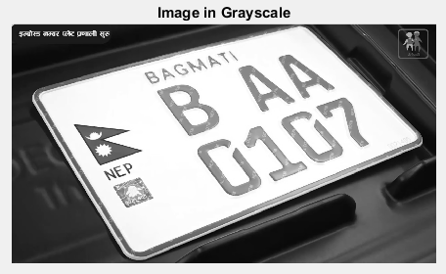

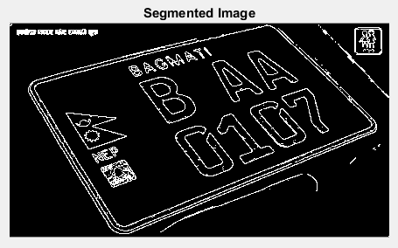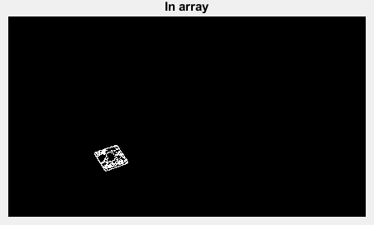

**CODE**

% Program 2 : Pattern Recognition

% Create a cascade detector object.

faceDetector = vision.CascadeObjectDetector();

% Read a video frame and run the detector.

videoFileReader = vision.VideoFileReader('video.mp4');

videoFrame = step(videoFileReader);

bbox = step(faceDetector, videoFrame);

% Draw the returned bounding box around the detected face.

videoOut=insertObjectAnnotation(videoFrame,'rectangle',bbox,'Face');

figure, imshow(videoOut), title('Detected Face');

**OUTPUT**

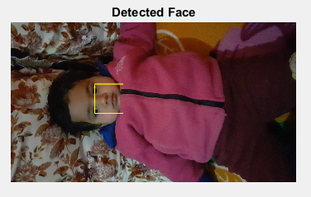

**CONCLUSION**

In this lab, I got familiar with image segmentation and pattern recognition. I also wrote a program to segment vehicle number plates from images and detect a human face from a video.